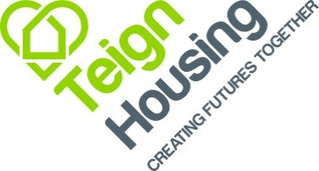

PERSON SPECIFICATION: Asset Management Administrator

Qualities | Essential | Desirable
Competencies | Good interpersonal and communication skills with people at all levels.  Flexible and able to work individually and as part of a customer focused team.  Able to deal in a professional manner with colleagues and external business contacts.  Able to demonstrate a high level of customer care.  Able to plan and manage own workload to meet deadlines.
Experience | Computer literate with basic MS Office systems | Experience of letting/ managing properties.  Experience of social housing.
Commitment | To provide the best possible service to customers and colleagues
Qualifications | Good standard of general education.
Special Conditions | NA
Other Attributes | Responsive, adaptable and self-motivated.  Ability to work within a busy pressured environment.  An understanding, caring and helpful nature.

