

**Regulator of Social Housing Key Measures 2024/2025**

As a housing provider, we are subject to regulation put in place by our regulator, The Regulator of Social Housing (RSH). They have identified key measures to see how well we are performing. The totals are worked out by adding the costs together and dividing them by the number of properties we have.

**How we spend your rent money**

As a not-for-profit social landlord, income collected from rents is invested into homes and services we provide.

The chart below shows a breakdown of how we have spent every £1 over the year:

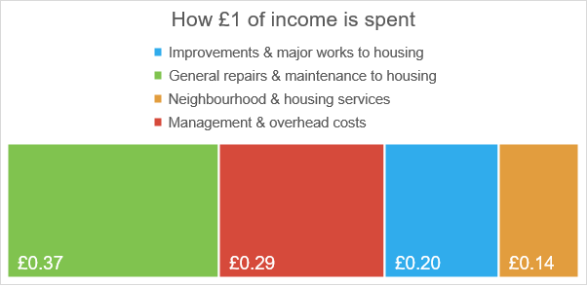

**Directors’ remuneration and management costs for 2024-25**

The remuneration payable to the highest paid Director, relative to the size of the landlord - £35.18

The aggregate amount of remuneration paid to Directors, relative to the size of the landlord - £166.10

Management costs relative to the size of the landlord - £1,773.88

*The figures are based on 3,936 properties which were owned or managed by Teign Housing on 31 March 2025.*