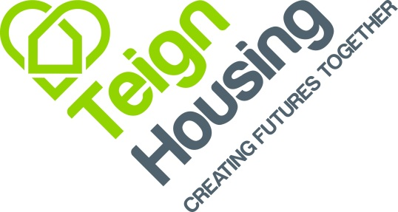

JOB PROFILE: IT Infrastructure Analyst

RESPONSIBLE TO: ICT Strategy & Infrastructure Partner

PURPOSE: To provide and maintain an efficient, secure and cost-effective IT infrastructure, software, telephony equipment, Housing Management Systems and digital corporate systems for Teign Housing and to assist in the discharge of the Company’s responsibilities.

To assist in the design and enhancement of the IT infrastructure and software applications that will support Teign Housings corporate objectives.

To work within the Company’s Equality and Diversity Policy, Health and Safety Policy, Customer Service and Performance Policies ensuring that these are complied with throughout all activities within the scope of this role to ensure the highest standards of customer care.

Ensure that all activities undertaken are carried out to the highest standards of integrity and professionalism in accordance with the Company’s policies and procedures.

Bring your skills, your ideas and your initiative to the role.

KEY ACHIEVEMENT AREAS:

Maintain an effective IT operational support function, including service desk and server support. This involves:

- Provide helpdesk support for hardware, software, telephony, web and digital corporate systems.

- Organise and deliver support services to ensure systems and users operate efficiently.

- Ensure network, infrastructure and systems operate at optimum performance.

- Install, configure and maintain software, servers, network components, communications and telephony equipment.

- Support setup, maintenance and repair of IT equipment and devices.

- Provide systems and tools to improve user productivity and routine tasks.

- Manage user access accounts to balance usability and strong security.

- Maintain IT security and ensure compliance with relevant legislation and standards.

- Support cyber security activities including penetration testing, Cyber Essentials and remediation actions.

- Ensure endpoint, workstation and infrastructure security best practice is maintained.

- Maintain accurate ICT asset registers and inventories.

- Maintain stock levels of IT consumables and accessories.

- Produce and maintain IT documentation including reports, procedures, user guides and records.

- Develop and maintain IT elements of the Business Continuity Plan.

- Liaise, coordinate and negotiate with third-party IT suppliers and support providers.

- Maintain awareness of emerging technologies and best practices.

- Contribute ideas, improvements and enhancements to IT services and systems.

- Collaborate with team members on projects to build knowledge and capability.

Health and Safety Responsibilities
- Take responsibility for own Health & Safety and not to put others at risk.

- To follow all guidance, policies and procedures associated with health and safety and ensure any risk assessments for this role have been read and understood.

- To comply with all health and safety legislation and regulations associated with the role. If in doubt, contact the Health and Safety Team for help and support.

No job profile can cover every issue, which may arise within the post. The IT team is small and team members will be expected to gain an understanding of each others’ roles and responsibilities to provide cover for holidays and absence. Accordingly the jobholder is expected to carry out duties requested by the line management from time to time.

Signed:……………………………………………………………………………………….

Date: …………………………………………………………………………………………

