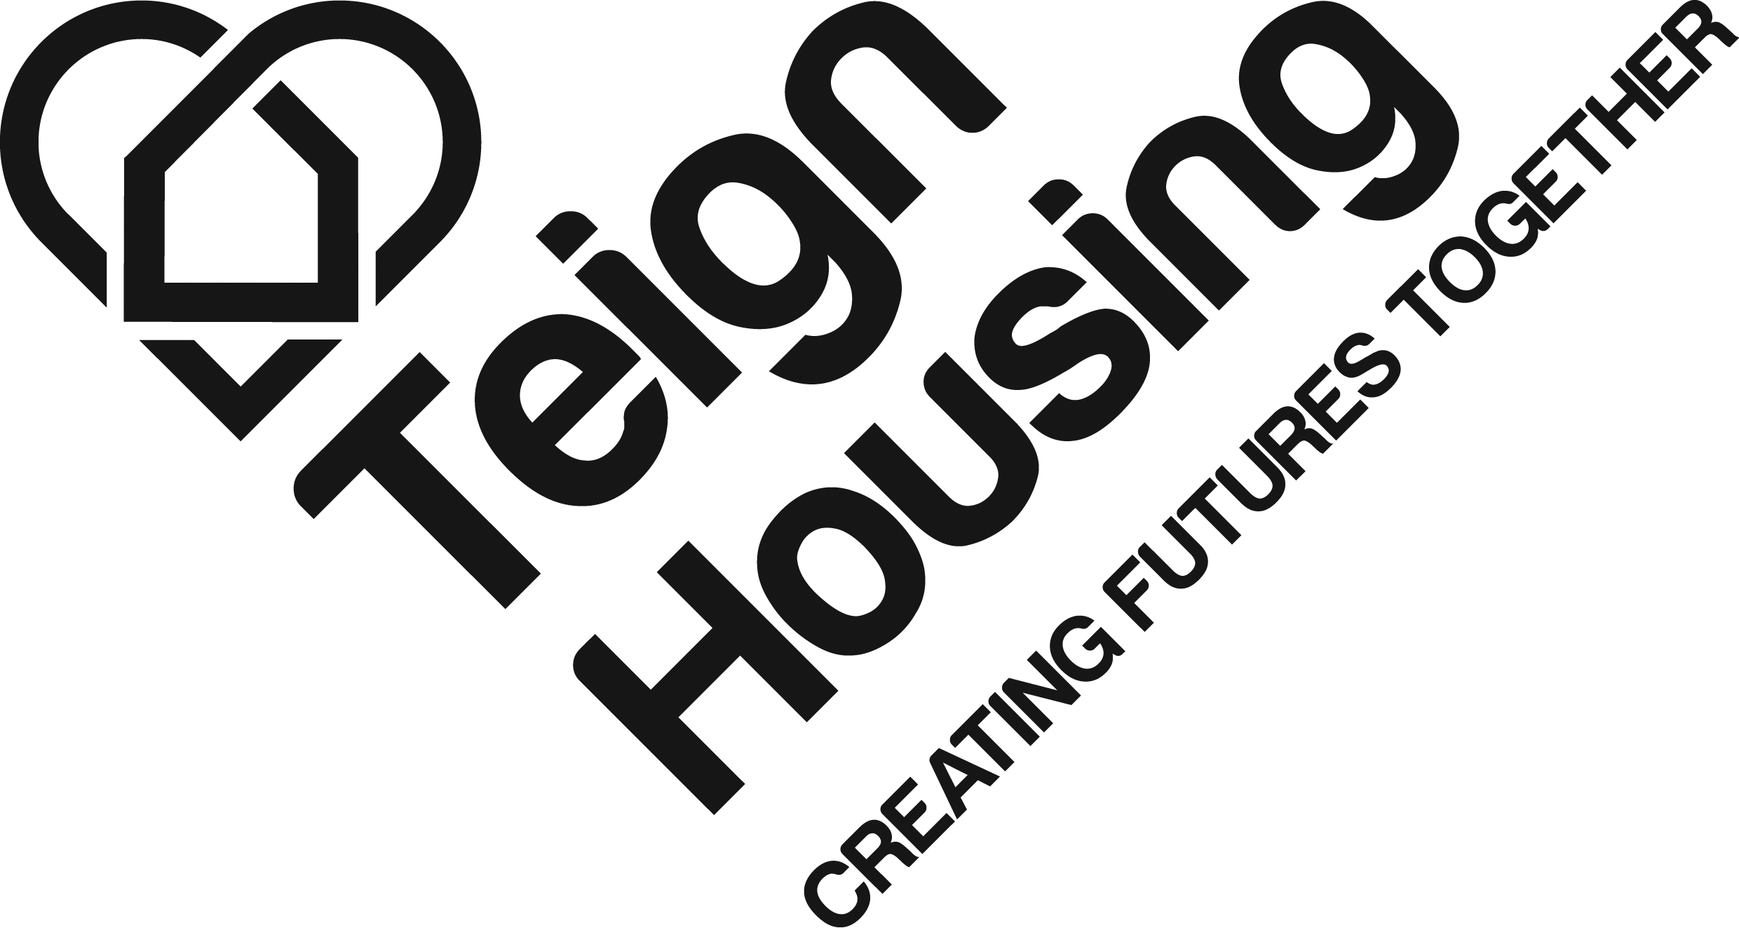

Tenants' Forum Community Chest
Application Form

What is the Tenants' Forum Community Chest?

The Tenants' Forum Community Chest is a £5,000 fund that Teign Housing sets aside for local community projects. From 1 April 2022 to 31 March 2023 we will be granting Community Chest awards, up to a maximum of £500 (no minimum amount).

Awards will be made to projects or events that will help improve the lives of Teign Housing tenants and the surrounding community in which they live.

Applicants must be able to clearly demonstrate how the proposed project or event will benefit the community, and that there has been consultation with local residents. A panel of Teign Housing residents from the Tenants' Forum will consider the applications and make decisions about awards.

All successful applicants are asked, as a condition of receiving a Community Chest Award, to submit full details for the money spent and complete an evaluation form outlining the success of the project.

How to make an application
Complete the application form and send it to Julie Cleave, Resident Involvement Manager, Teign Housing, Millwood House, Collett Way, Newton Abbot, TQ12 4PH, or email Julie.cleave@teignhousing.co.uk

If you need any help completing the form or want to talk about your project to see if it would be suitable, please contact Julie Cleave, Resident Involvement Manager at Teign Housing, 01626 322751 or email Julie.cleave@teignhousing.co.uk

Please allow up to three weeks for applications to be considered.

1. Contact details of the person who is making the application:

Your name:

Name of community group (if applicable):

Contact address:

Postcode:

E-mail:

Contact number(s):

2. What is your project? Use this space to give a brief summary of your proposal.

3. What are the benefits of your proposal?

4. If your application is successful, approximately how many people will benefit?

Adults
Others

Young children
Teenagers

5. Who have you consulted about your idea?

6. How have you consulted them? (For example, residents’ meeting, coffee morning, door to door survey, social event, other informal discussions)

7. Use this space to give any other information that you feel may help us to consider your application, and attach a map or sketch of location, where appropriate.

8. How much is your project or community amenity going to cost, and how much do you need from the Community Chest?

Item Cost Grant requested

……………………………… …………… …………………

……………………………… …………… ………………….

……………………………… ……………. ………………….

………………………………. ……………… …………………

……………………………….. …………… ………………..

……………………………….. ……………. ………………..

Totals …………….. ……………….

Continued →

PRIVACY INFORMATION

Teign Housing is committed to providing our customers with the highest standards of privacy and data security in accordance with the General Data Protection Regulations (GDPR).

The personal information you supply in this form including: name, address and contact details, will be used solely for the purpose of assessing your application, and will be securely stored by Teign Housing in line with our Data Retention Policy. Your personal information will not be shared or sold to any other third parties unless required by law.

To enable us to legally process your personal data, we will require your prior consent:

- I grant my consent for Teign Housing to hold my personal data for the purposes described above (please tick)

For further details about how Teign Housing manages your personal information, or for more information regarding your rights under the ‘GDPR’, please visit our website www.teignhousing.co.uk, email your enquiry to customerhub@teignhousing.co.uk , or alternatively, contact our Business Support Team by calling 01626 322722.

Signed ………………………………………….

Date ………………………………………........

Please return your completed form to:

Julie Cleave, Resident Involvement Manager, Teign Housing, Millwood House, Collett Way, Newton Abbot, TQ12 4PH or email Julie.cleave@teignhousing.co.uk

